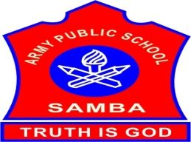
ARMY PUBLIC SCHOOL SAMBA
WEEKLY REPORT
AUGUST 07,2023-AUGUST 12,2023

SCHOOL EVENTS

WORKSHOP ON SCHOOL HEALTH AND WELLNESS PROGRAM (AUGUST 11-12,2023)
A two days’ workshop on ‘School Health and Wellness’ was organized by APS Damana on August 11-12,2023.Three teachers from APS Samba attended the same: Ms Indu Bala(PGT Hindi),Ms Priya Bhagat(TGT Science) and Ms Sapna Choudhary (Special Educator).
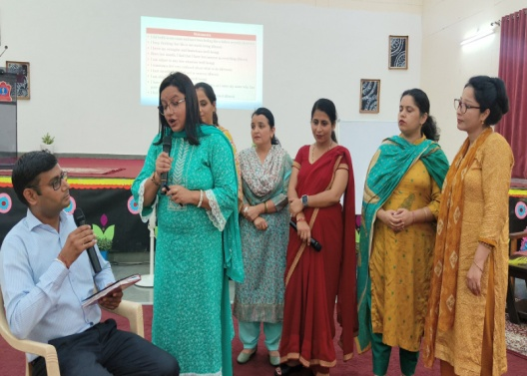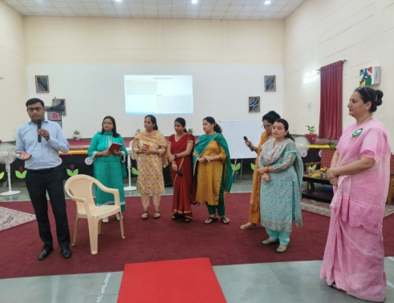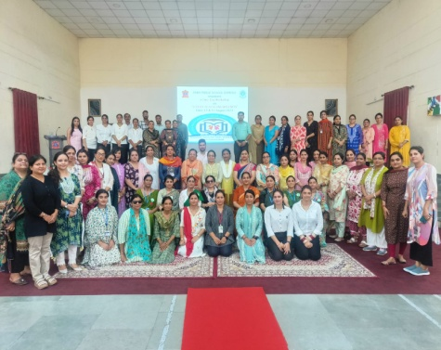

INTER HOUSE BADMINTON MATCH (FINALS) (IX-XII) (AUGUST 10,2023)
Inter house Badminton match (Finals) for IX-XII boys and girls was organized on August 10,2023 in the MP Hall of APS Samba.The final matches were played between Nehru house and Teresa house.The result of the matches is as follows:
BOYS: Nehru House- First Position GIRLS: Teresa House - First Position
Teresa House- Second Position Nehru House - Second Position
Gandhi House- Third Position Gandhi House- Third Position
Sarojini House- Fourth Position Sarojini House- Fourth Position
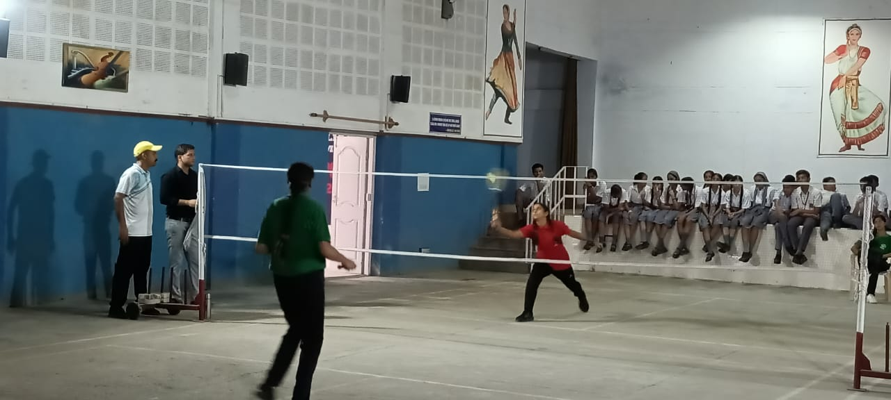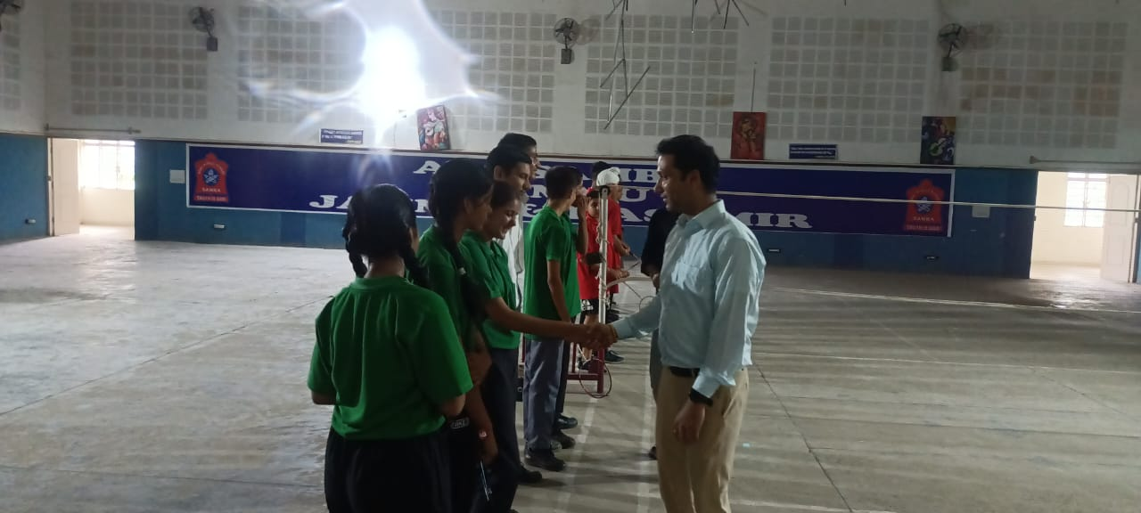

INTER HOUSE KABADDI MATCH (FINALS) (VI-VIII) (AUGUST 10,2023)
Inter house Kabaddi match (Finals) for VI-VIII boys and girls was organized on August 10,2023 in the Foot ball ground of of APS Samba.The final matches were played between Nehru house and Teresa house.The result of the matches is as follows:
BOYS: Nehru House- First Position GIRLS: Sarojini House - First Position
Teresa House- Second Position Teresa House - Second Position
Sarojini House- Third Position Nehru House- Third Position
Gandhi House- Fourth Position Gandhi House- Fourth Position

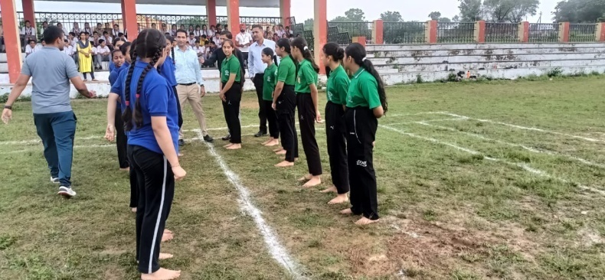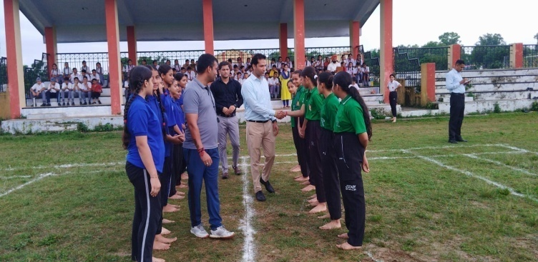

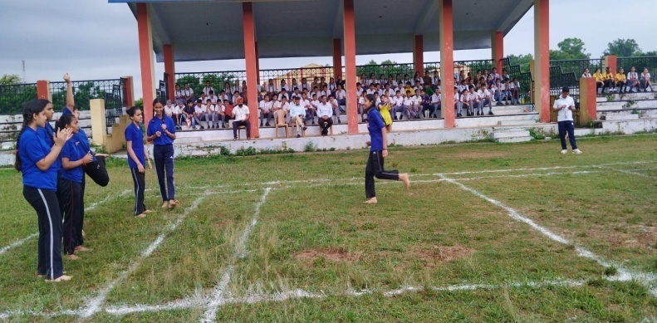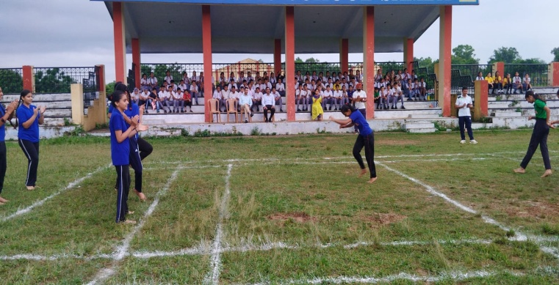

INDEPENDENCE DAY CELEBRATION (AUGUST 11,2023)
On August 11,2023, the patriotic spirit filled the air at APS Samba as the school celebrated 77th Independence Day with great enthusiasm in the Primary as well as Secondary Wing.On this occasion a special assembly was organized marking a memorable start to the day. Students presented patriotic songs, skit and poems.There was a feeling of pride and patriotism in everyone’s heart. The NCC cadets also performed captivating dance drama to showcase their heartfelt tribute to the nation. The performance was a beautiful fusion of artistic expression and patriotism, leaving a lasting impression on the entire school community .In the end, the Principal addressed the students and the teachers.He told about the supreme sacrifice of the great martyrs who gave their lives for the sake of freedom. He also said that the freedom was very precious and it was very necessary to preserve it.He also advised the students to become ideal citizens of the country.
PRIMARY WING
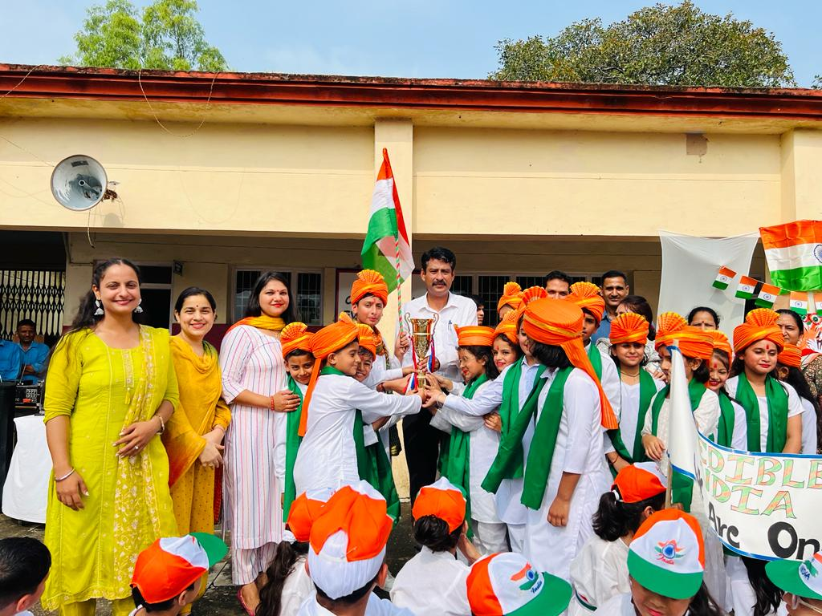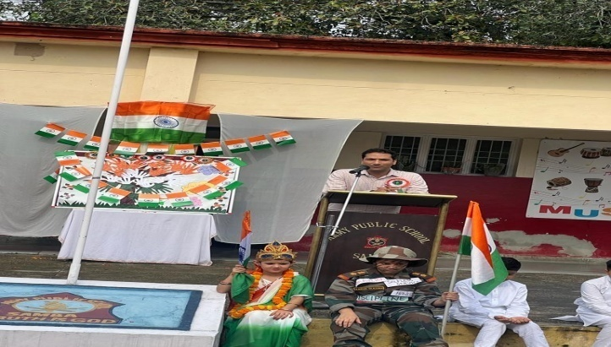

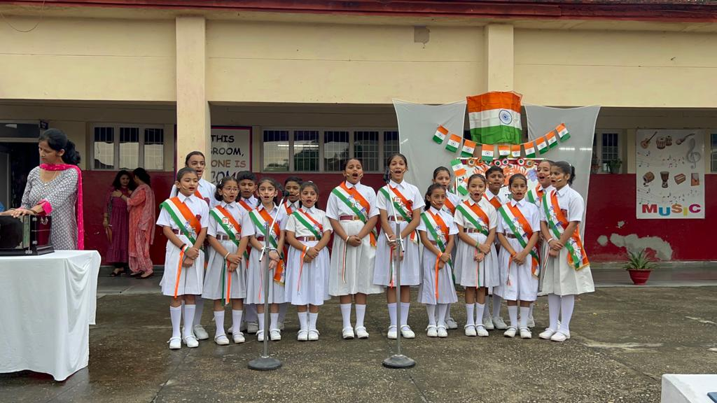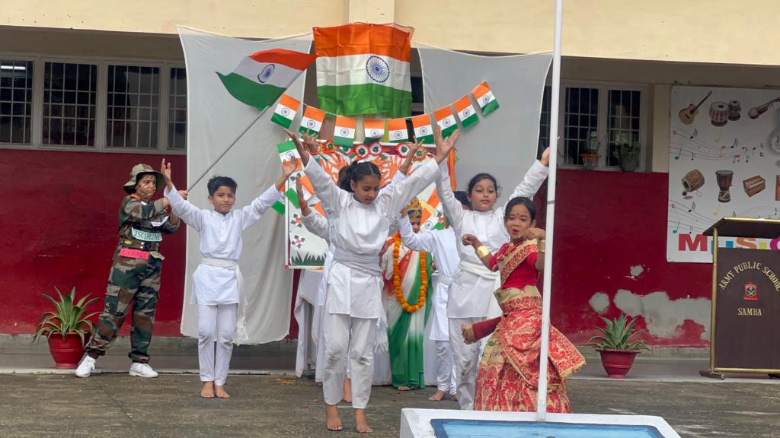

SECONDARY WING
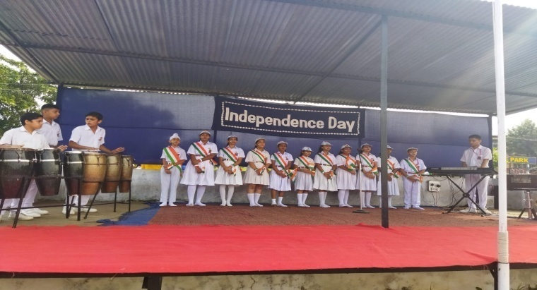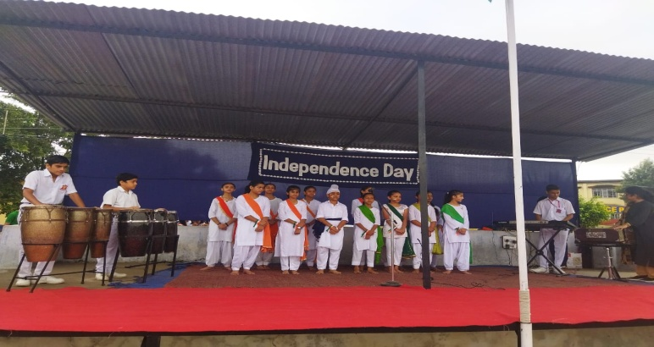

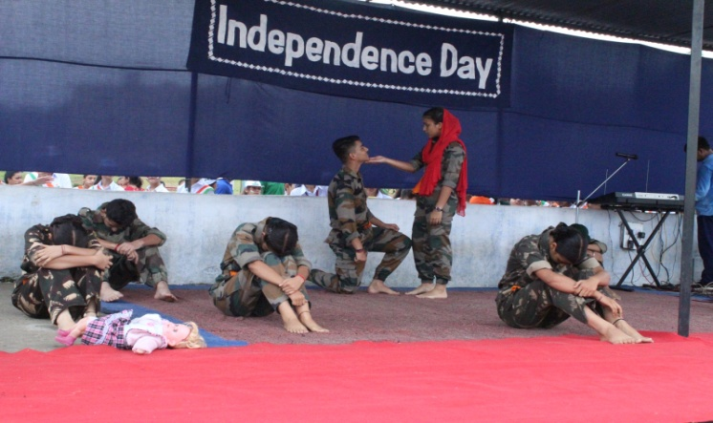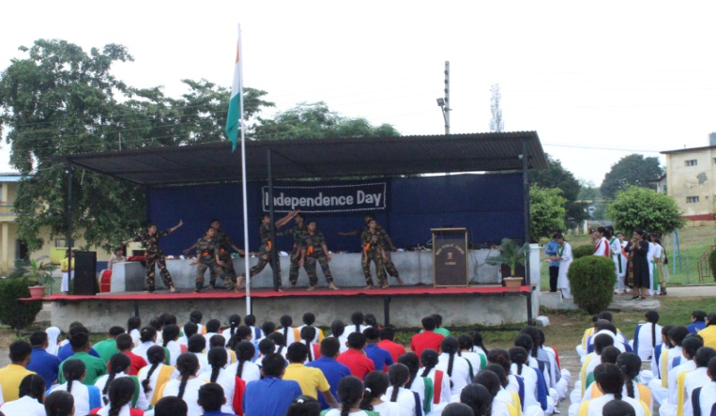

NIAS-ALC OFFLINE SESSION (AUGUST 09,2023)
Offline session of NIAS- ALC was conducted on August 09,2023. Class was fully interactive and students took part in the discussion with great interest.
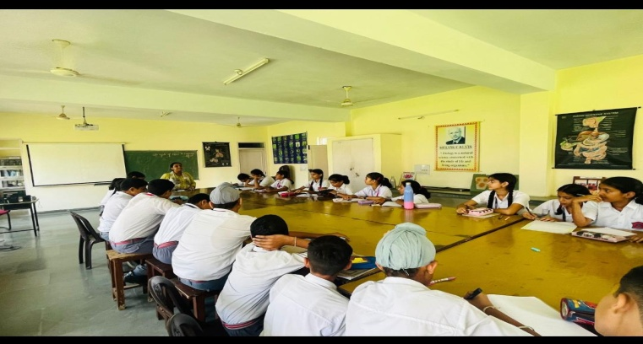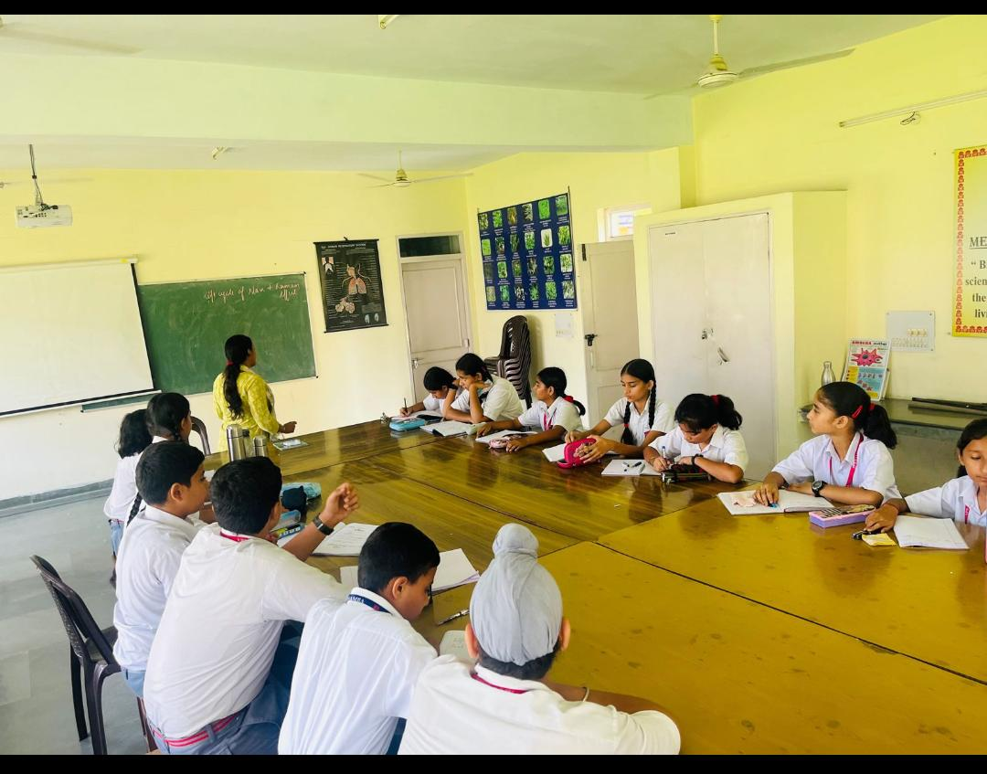

IN-SERVICE TEACHER TRAINING (AUGUST 12,2023)
To update teachers' skills and knowledge for improving teaching and learning and to face new challenges and changes in the world of education, an in-service teacher training was organized for the Primary teachers on August 12,2023 in the Primary Block of APS Samba.The training started with the Yoga session taken by Ms Aradhna.After the Yoga session the first session was taken by Ms Mandeep Kour (PRT) who presented her views on “Happy Classroom”.Afternoon session was taken by Ms Esha Sharma on “Effective Communication”.All the Primary teachers attended the training.
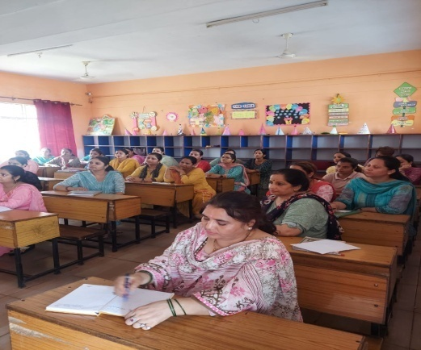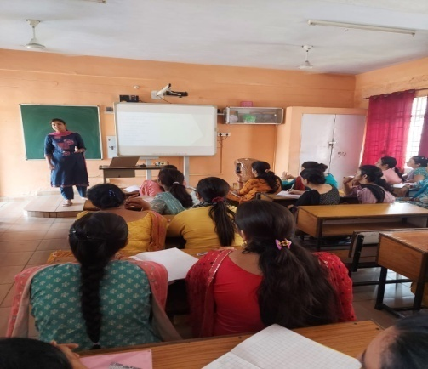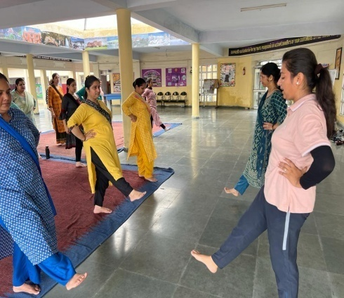

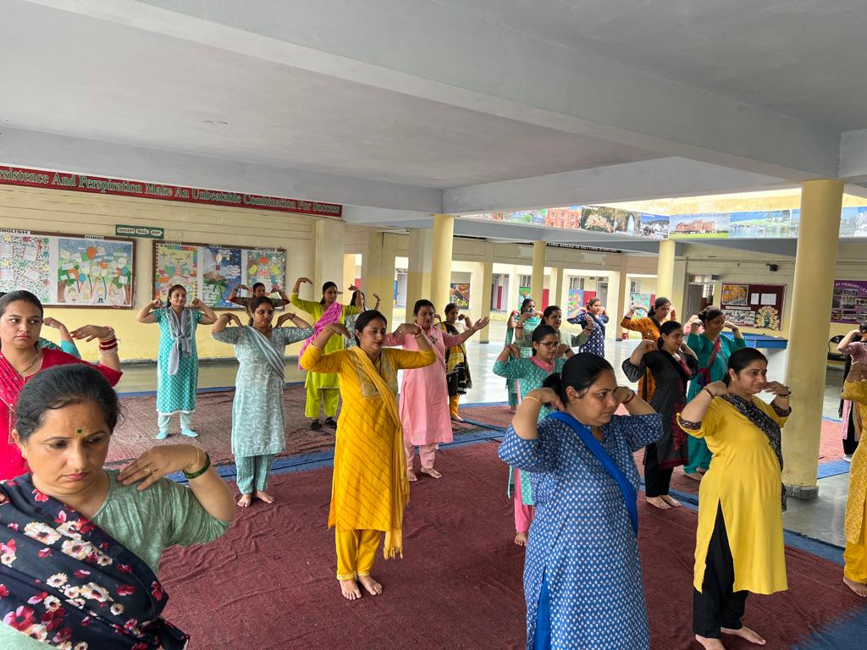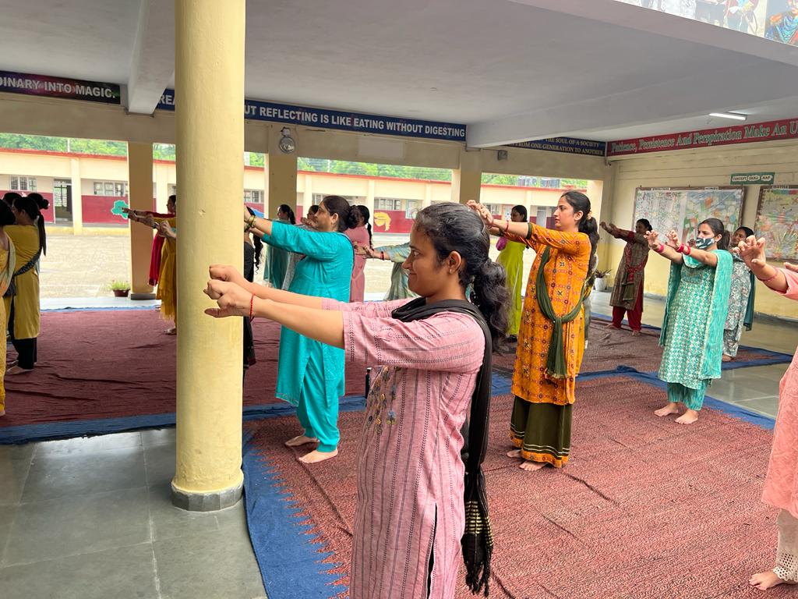

WORKSHOP ON VEDIC MATHS ( 09,2023)
Vedic Mathematics is the ancient system of calculation which was drawn from the Vedas, between 1911 and 1918 in India. The advantage of Vedic Mathematics is that it allows for uncomplicated problem-solving methods for difficult arithmetic problems and large sums. In order to equip the students with the nuanced techniques of VEDIC MATHS, a workshop on Vedic Maths was organized for all the teachers in the AV Room of APS Samba on August 09,2023.Mr Punit Ahuja, Director & COO of G. A. Future Educore Pvt. Ltd & R.P.Skill and Education Development Trust was the resource person.The main motto of organizing this workshop was to remove the phobia of Maths from the students. The workshop sought to apprise teachers of tricks that they could make their students employ to make their calculations faster and accurate - whether it be finding the cube roots of big numbers, multiplication of a number with a number of Nines or for two-digit multiplication. Teachers were greatly benefitted from this workshop.

TRICOLOUR TIFFIN PARTY FOR CLASSES I& II (AUGUST 11,2023)
A Tricolour tiffin party was organised for the students of classes I and II on August 11,2023.Little tiny tots of APS Samba celebrated INDEPENDENCE DAY with fun, healthy, easy and delicious recipes that are naturally tri coloured.
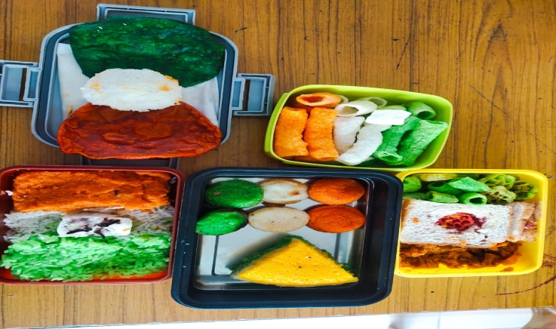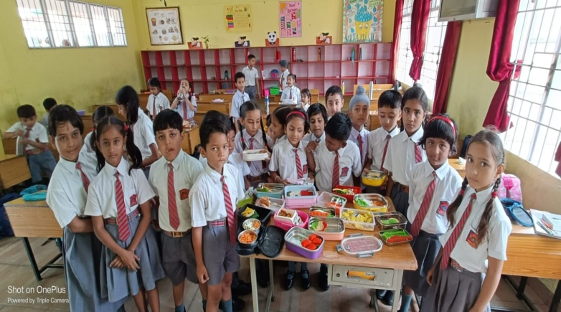

INTER HOUSE PATRIOTIC GROUP SONG COMPETITION (AUGUST 11,2023)
To bring out the singing talent of students, Inter-House Group Song Competition was organized in the Primary as well as Secondary block of the school for the students of classes III-V and VI to VIII on August 11,2023 in the morning assembly.The theme for the competition was Patriotic Song.The four groups from the four houses put forth their enthralling performance.The children sang the songs with confidence and passion.

PRIMARY BLOCK

SECONDARY BLOCK

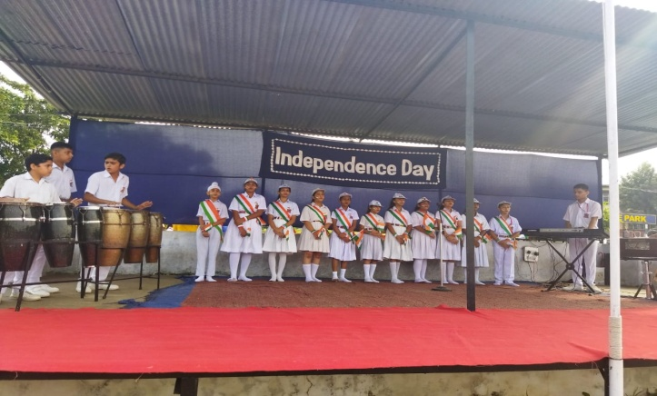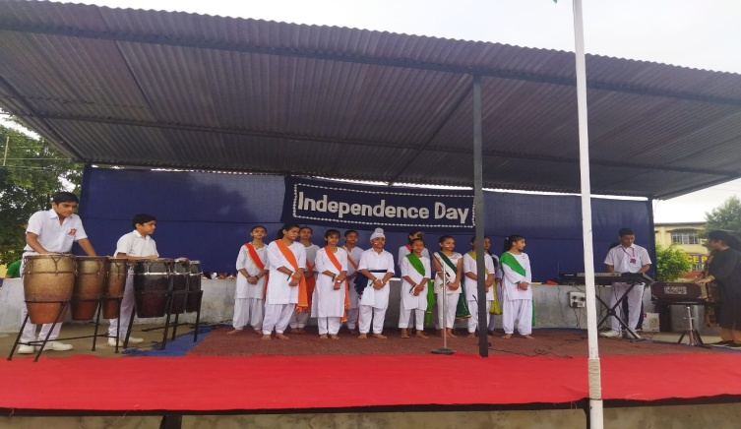

AZADI KA AMRIT MAHOTSAV –CULMINATING EVENT (AUGUST 09-15,2023)
Under Azadi ka Amrit Mahotsav Culminating Event
Panch Praan Pledge was taken under "Meri Maati Mera Desh" campaign, by the NCC Cadets, students ,teachers and Principal APS Samba on August 09,2023.

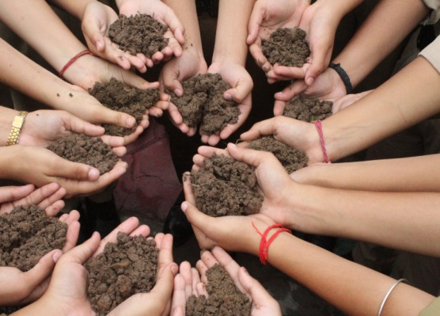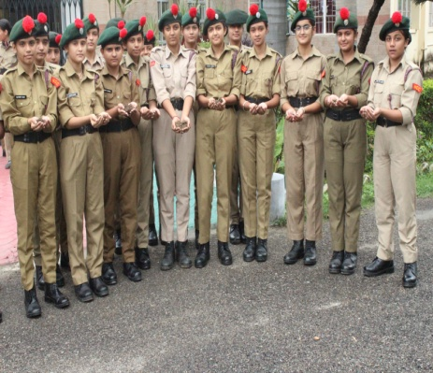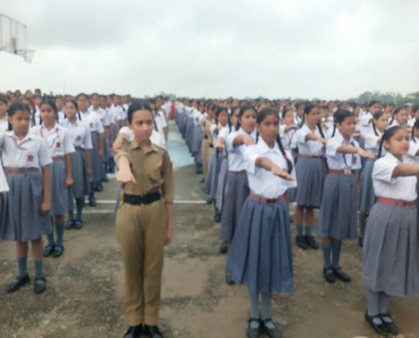
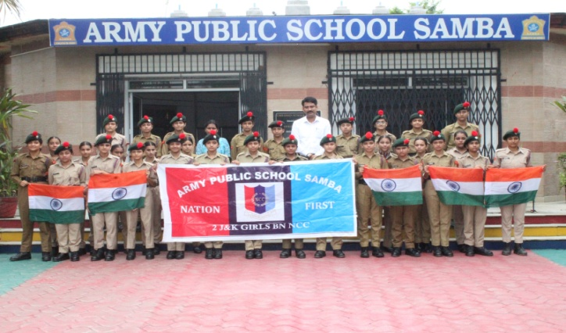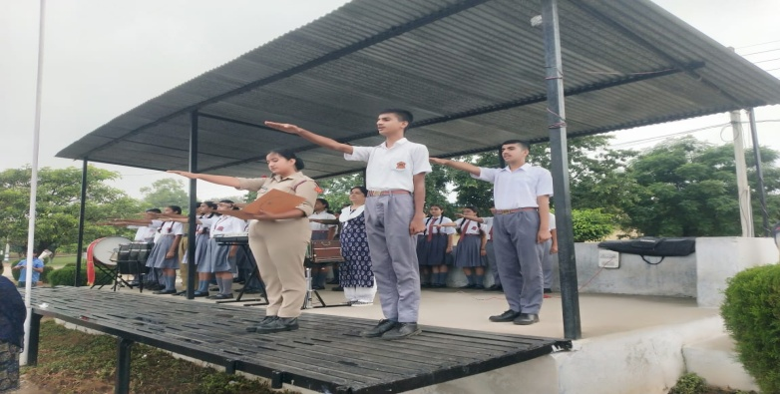

PRIZE DISTRIBUTION CEREMONY (AUGUST 09,2023)
A special assembly was organized on August 09,2023 to felicitate the students who participated in second level of various Olympiads conducted by SOF and emerged as zonal toppers and won medals of zonal excellence along with the cash award.
The Olympiads were conducted in an endeavor to develop a greater competitive spirit, better assessment and exploration of potential among students.Miss Parneet Kour was also felicitated by the Principal for winning Gold Medal in International Dance and Acting Competition held at Kathmandu,Nepal.

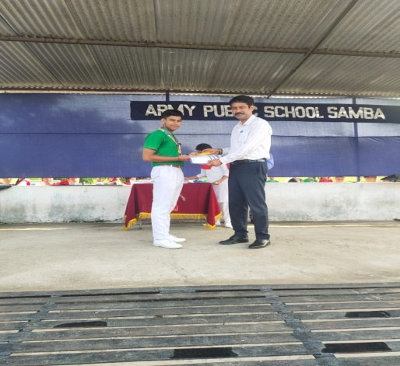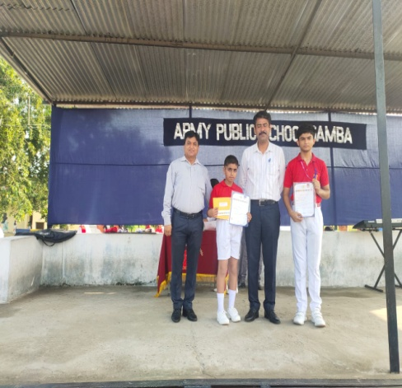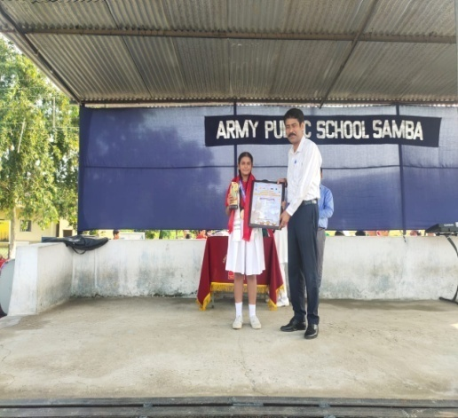

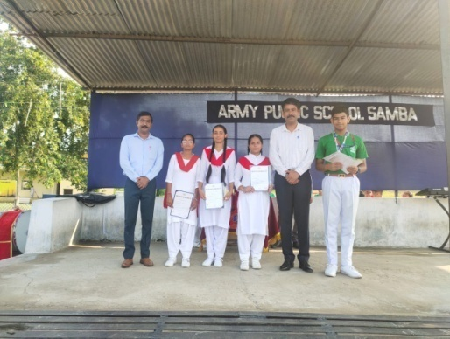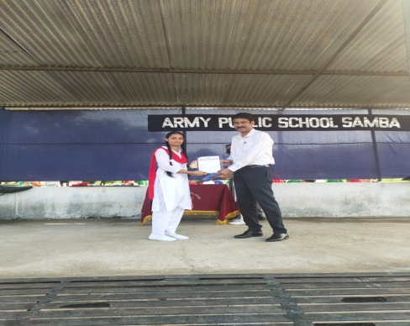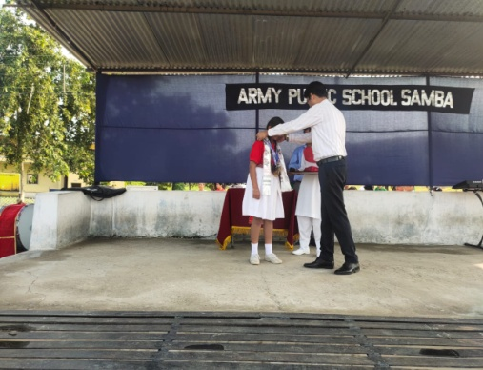

THANK YOU

